**Name**:

**Level**:

**Stat Points:**

**Max Health:**

**Who** are you? Who’s your family? Who do you want to be?

**What** are you? What do you look like? What do you own?

**When** in your life are you adventuring?

**Why** are you adventuring? Why with this group?

**Where** did you come from? Where are you going?

## Roleplaying

Roleplaying, like smashing doors open, picking locks, providing medical care, or bartering, may cause your GM to ask you to **roll 1d6 with one of your Stats.**

**Add your Roleplay Bonus from the relevant Stat!**

When Roleplaying **in** **combat**, **spend 1 AP to roll 1d3.**

You can **spend more AP to add extra dice** to these rolls   
(1 AP per 1d3).

](https://rolladie.net/)

## PIT

PIT stands for **Points in this Tier.** Each Stat has 6 tiers.

Playersstart with3 PIT in each Stat’s first tier.

## Rolling for Criticals

Roll 1d6 when using Actions that **deal damage or heal.**

If you **roll a 6, add double your level** when determining how much damage you deal/heal.

**Leveling Up**

Players have 10 Health and 4 Stat Points (SP) **per level.**

To **put SP in a tier**, you need **6 PIT in the prior tier**.

Putting 1 SP in a tier unlocks **everything in that tier.**

**Items**

Spend 1 AP to use a Fast Item.

Spend 2 AP to use a Normal Item.

Spend 3 AP to use a Slow Item.

Spend 4+ AP to use Special items.

**Rolladie.net**

## Action Points (AP)

Spend AP to do Actions. Describe them however you want!  
**Ranged actions** cannot shoot through inaccessible Zones.

All players have **6 max AP**, which are **restored** at the start of the Player Phase. You can track your AP with a d6!

Scharisma RP Bonus: + __

Flirt | Lie | Convince  
Detect Lie| Demotivate| Pray  
Assist | Entertain | Motivate

Support RP Bonus: + __

Examine | Investigate Empathy | Pray | Commune | Rescue Motivate | Assist

Skill RP Bonus: + __

Dodge | Jump | Lockpick  
Juggle | Backflip | Steal  
Lift | Catch | Assist | Sneak

Strength RP Bonus: + __

Smash | Pull | Break Assist | Lift | Jump   
Push | Hold | Persevere

Roleplaying Quick Reference

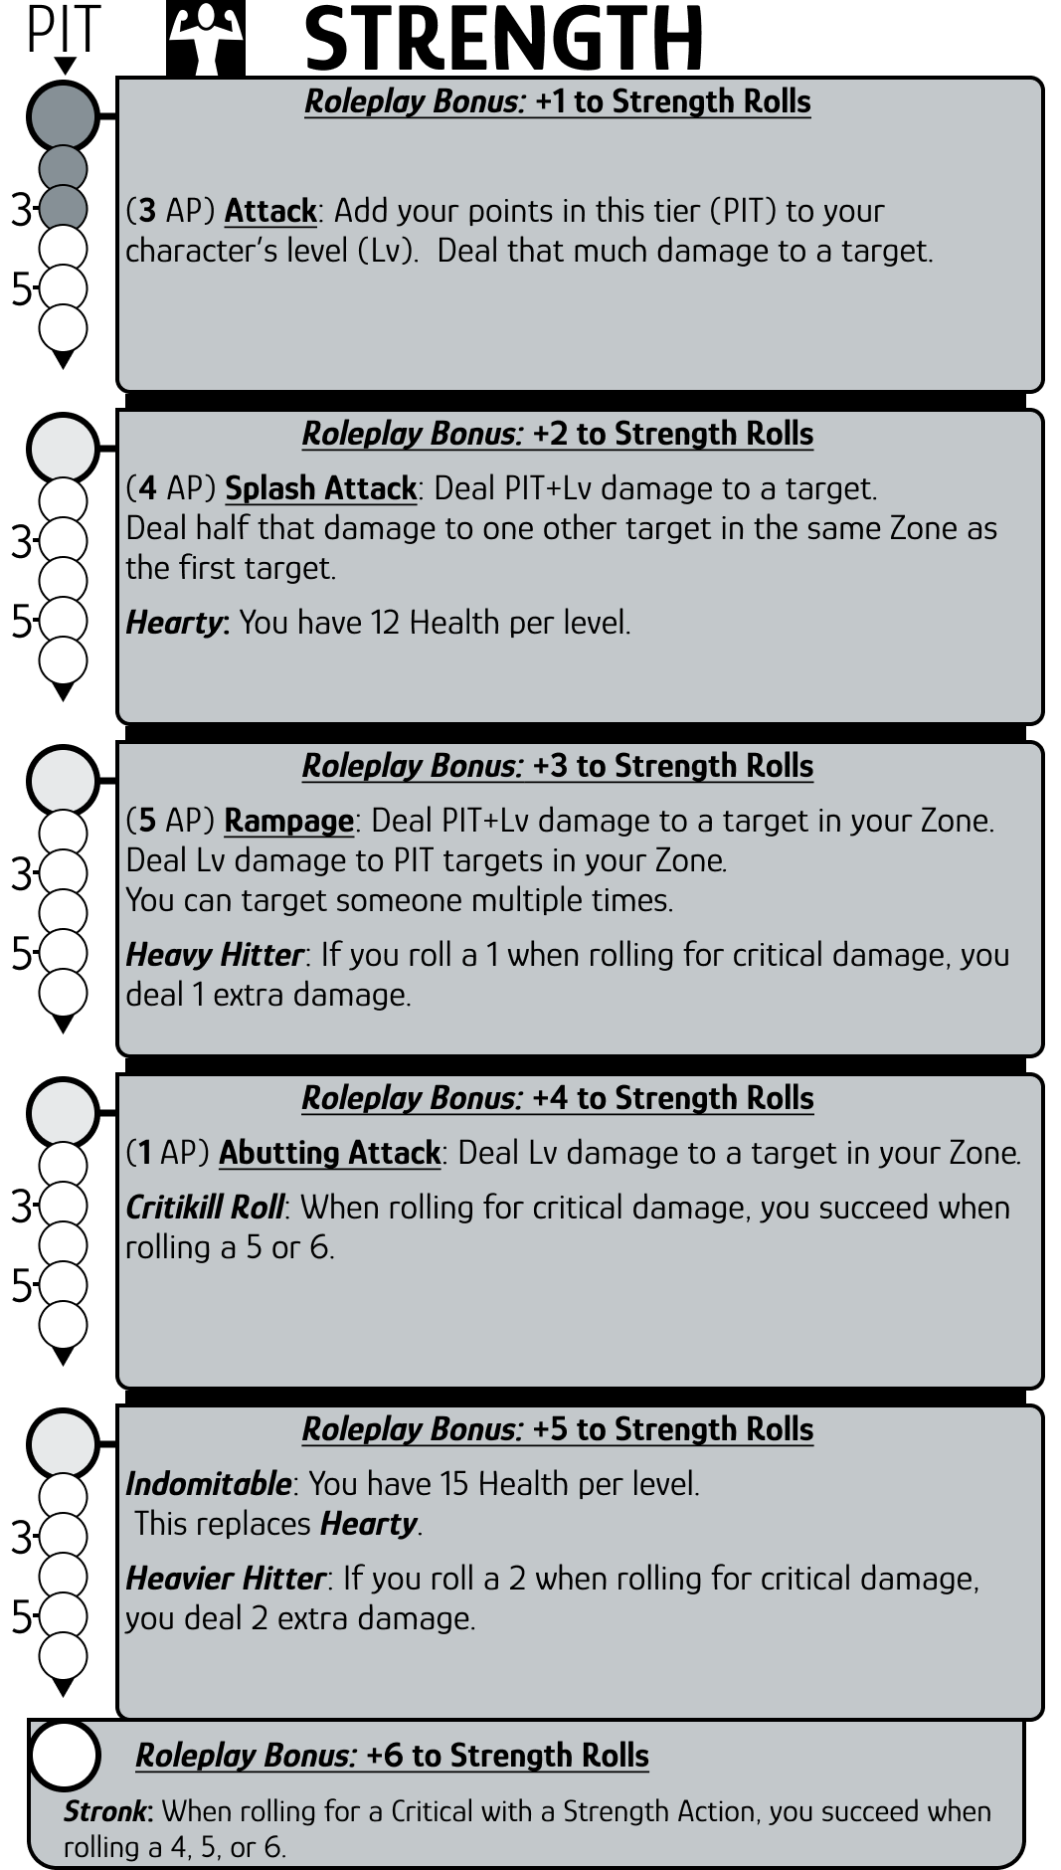

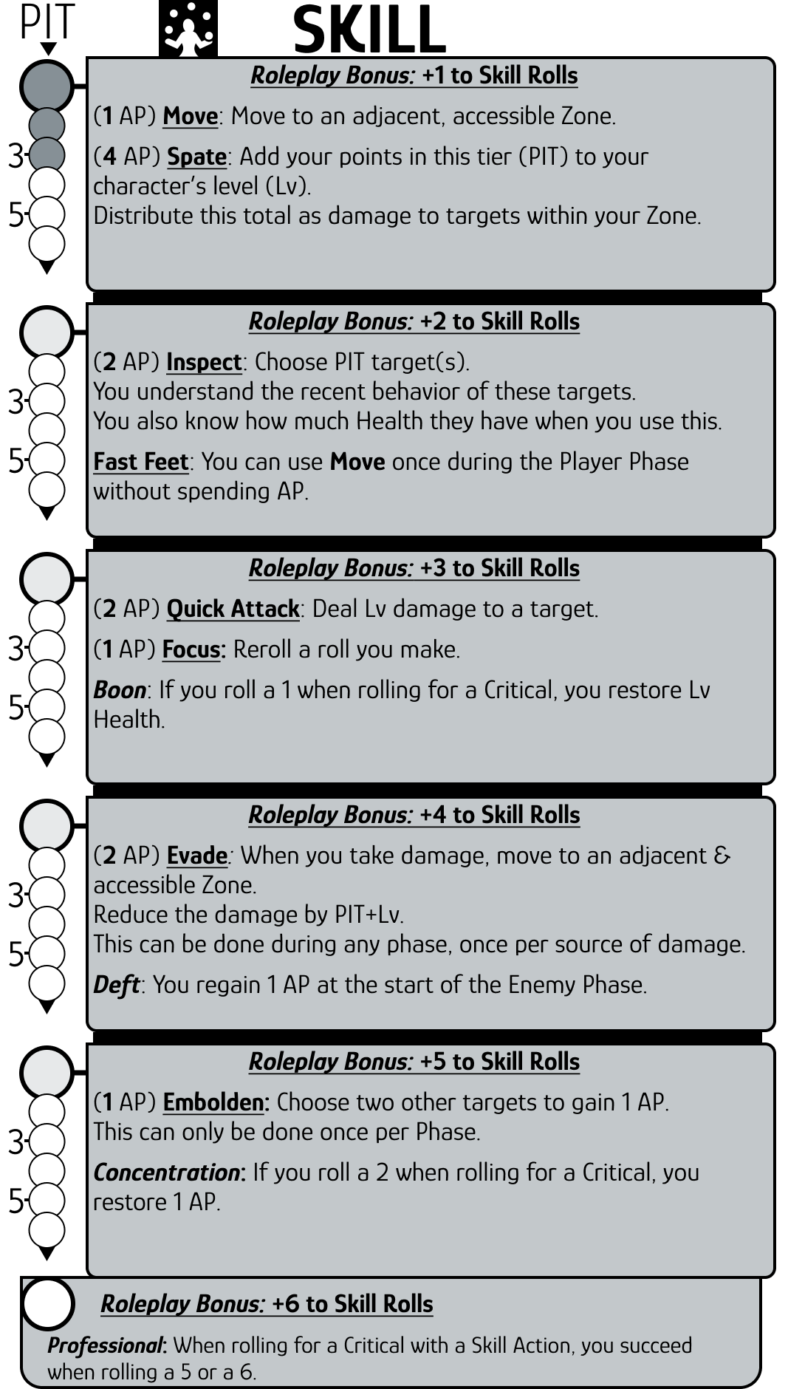

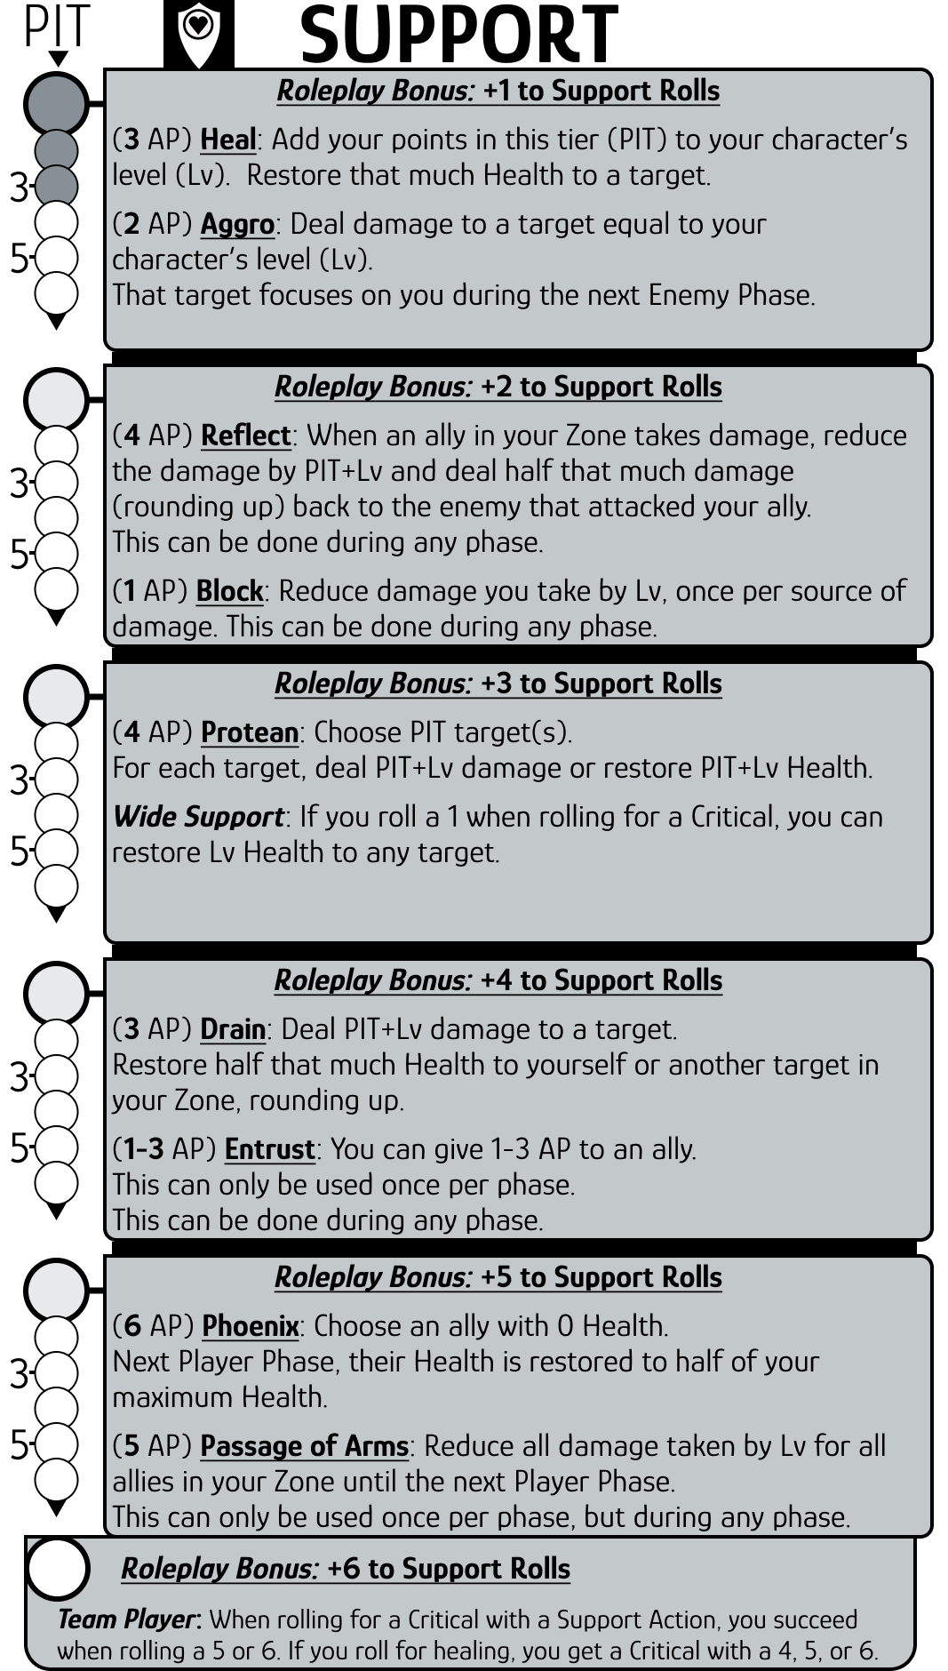

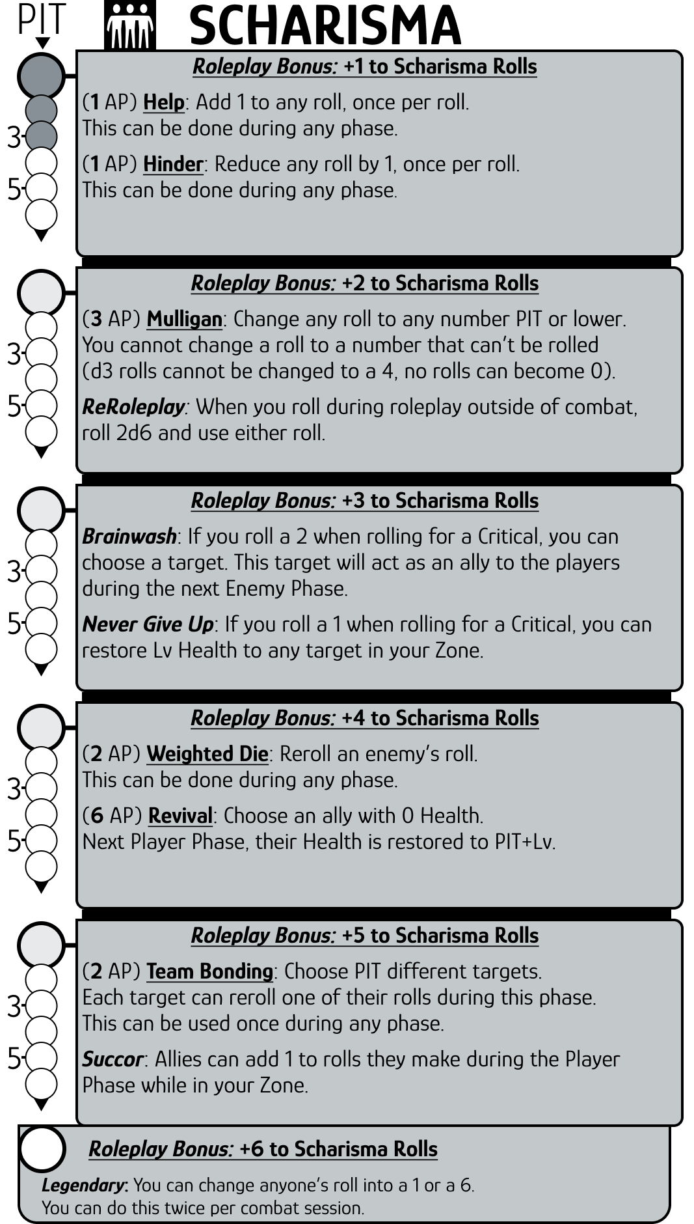

**NOTES**